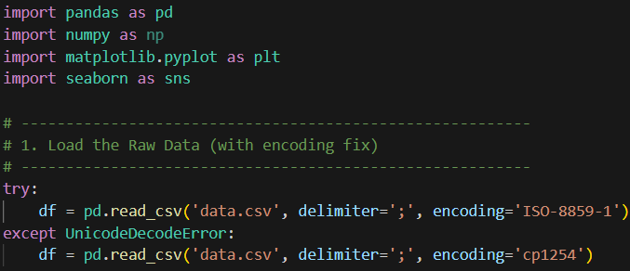

This code imports essential libraries, then loads the dataset using a try-except block to automatically handle the file's semicolon separators and fix character encoding errors.

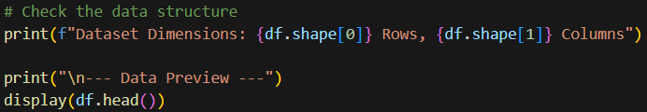

This step performs an initial data inspection by outputting the dataset's dimensions (rows and columns) and displaying the first five records.

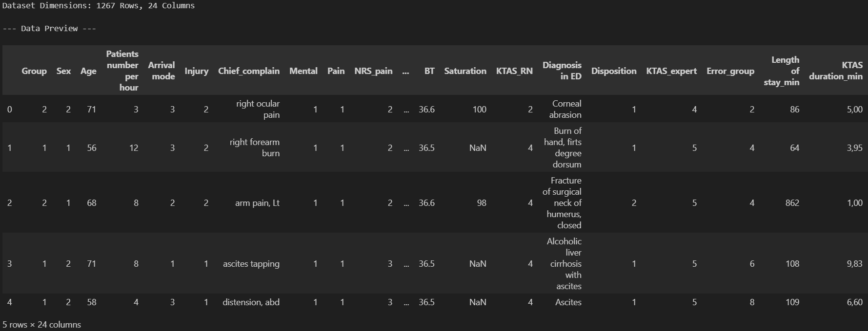
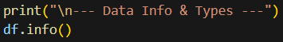

This code generates a structural summary of the dataset, listing all column names, their data types, and the count of non-null values.

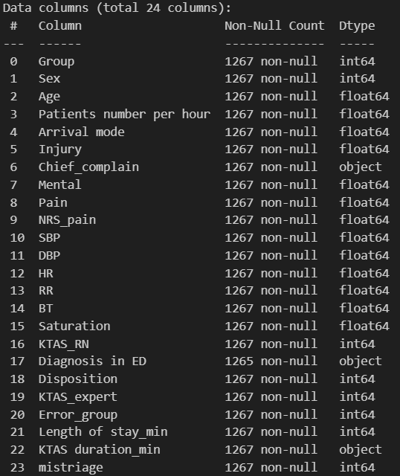

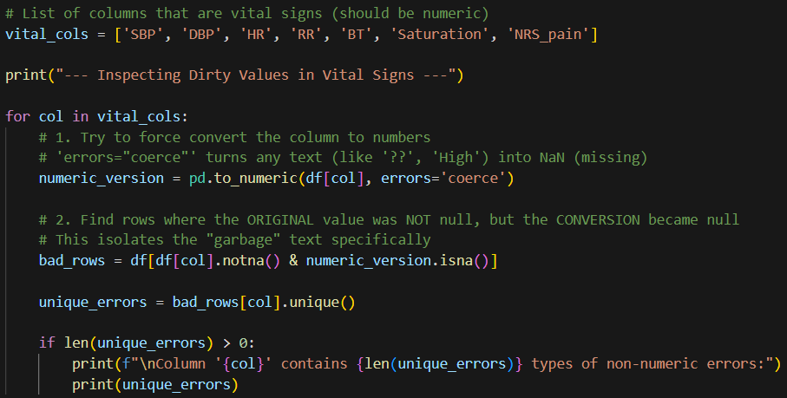

This method systematically identified any non-numeric entries (such as '??' or '#BOÞ!') by attempting to convert all values to floats and flagging instances where the conversion failed despite the original data being present. This approach ensures all forms of data corruption are detected, regardless of the specific characters involved.

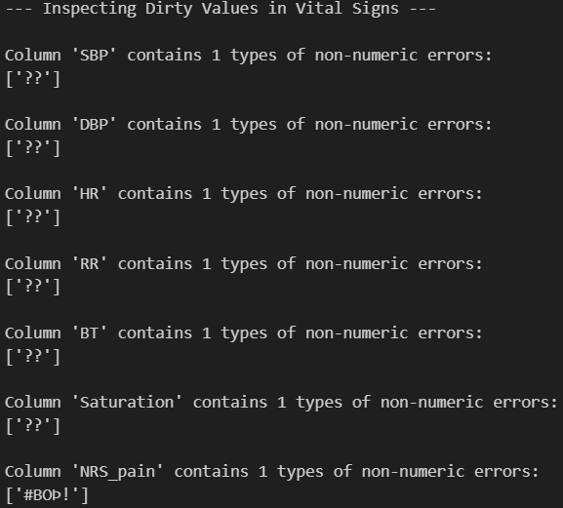

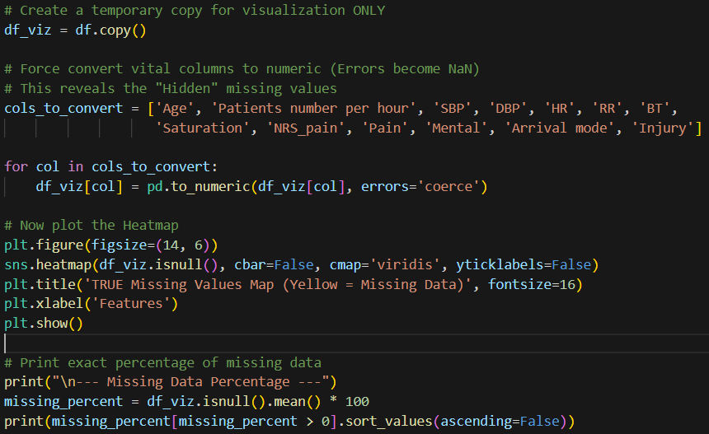

This code forces columns that should be numbers to actually become numbers, turning any hidden text or errors into obvious "missing" blanks. Then, it creates a visual map to show exactly where these holes are and calculates the precise percentage of missing data.

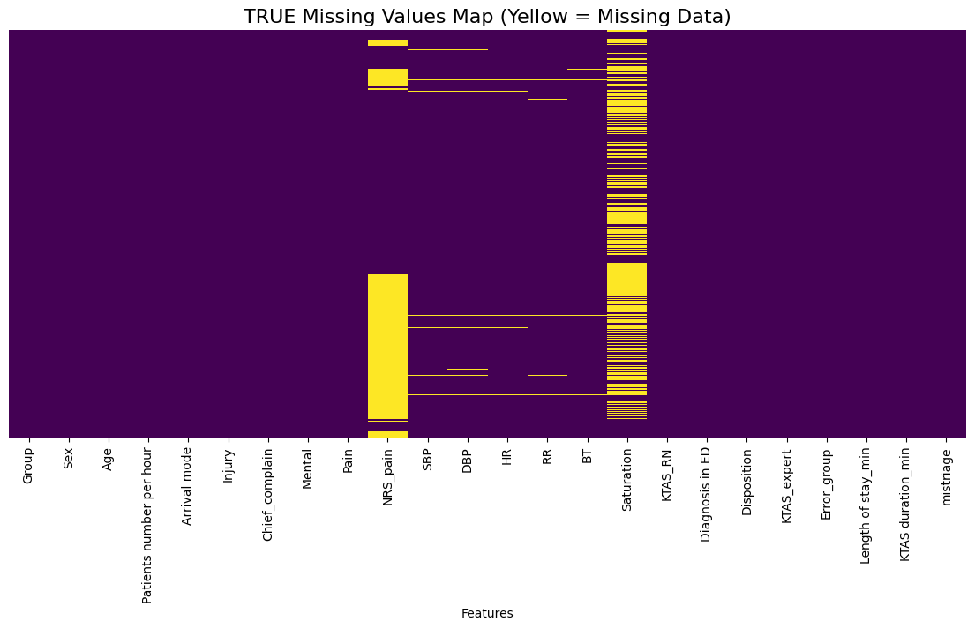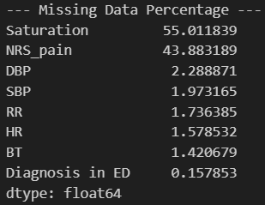

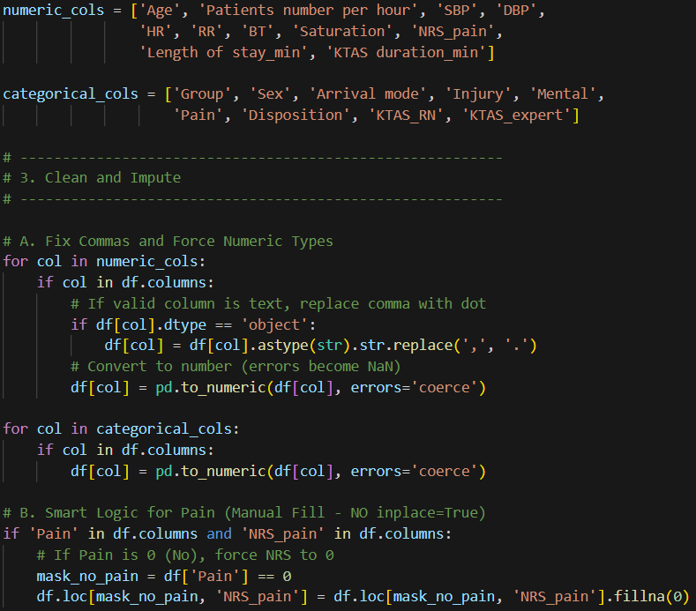
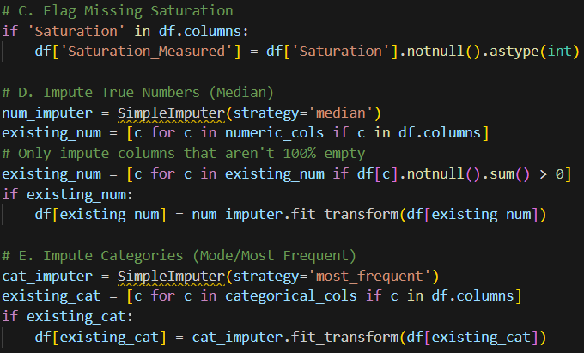
This code acts as a comprehensive data cleaning and preparation pipeline that transforms messy raw records into a complete dataset ready for analysis. It starts by distinguishing between numerical data (like blood pressure) and categorical data (like gender) to ensure each is treated correctly, while simultaneously fixing formatting errors by converting decimal commas to dots and turning invalid text into blank values. To maintain medical accuracy, it applies logical rules such as automatically setting pain scores to zero if a patient reported "No Pain" and flagging missing oxygen levels so the model understands they weren't measured, before finally filling in all remaining gaps using the median for numbers (to ignore outliers) and the most frequent value for categories.

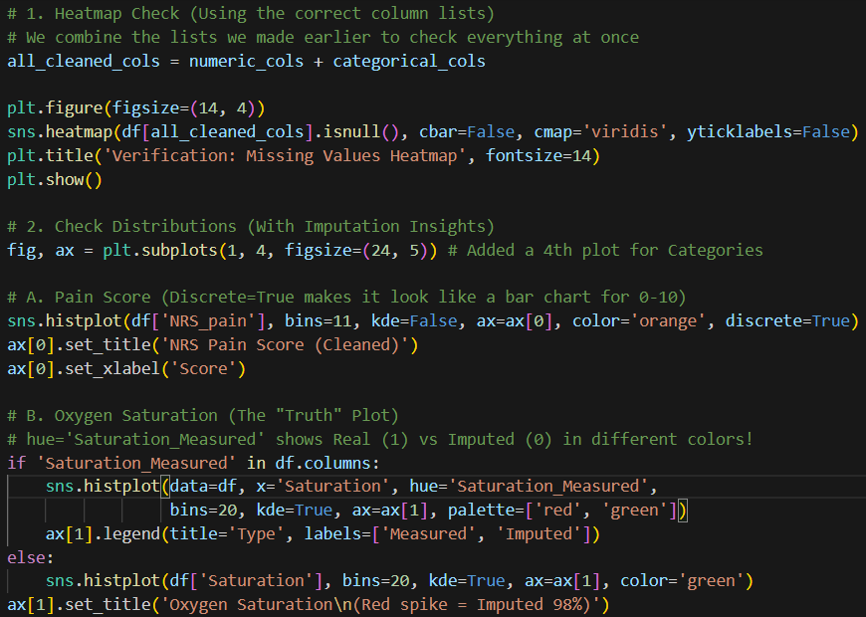
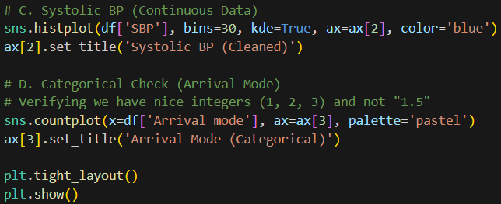

This code creates a visual "health check" to confirm data cleaning and imputation were successful. First, it generates a heatmap to verify there are no missing values left. Then, it plots four charts to inspect the quality of your variables: a histogram for Pain Scores, an Oxygen Saturation plot that color-codes "Real" vs. "Imputed" data, a standard distribution curve for Blood Pressure, and a count plot for Arrival Mode to ensure categories are clean integers rather than messy decimals.

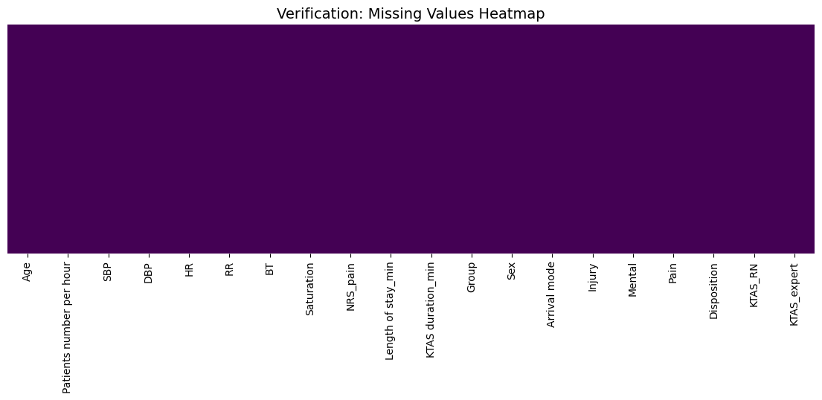
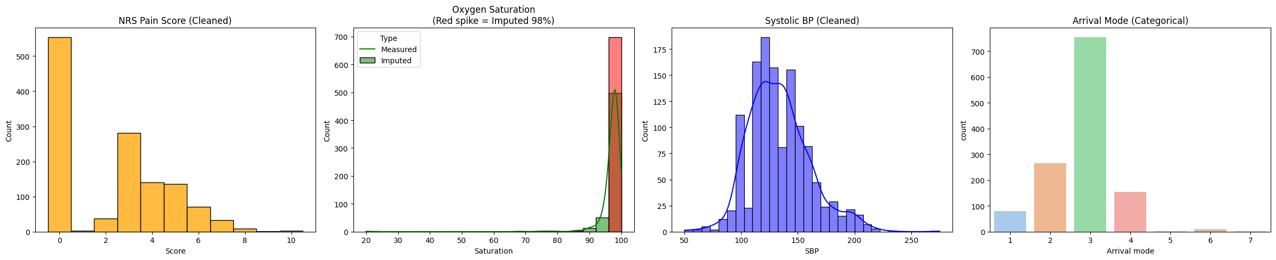

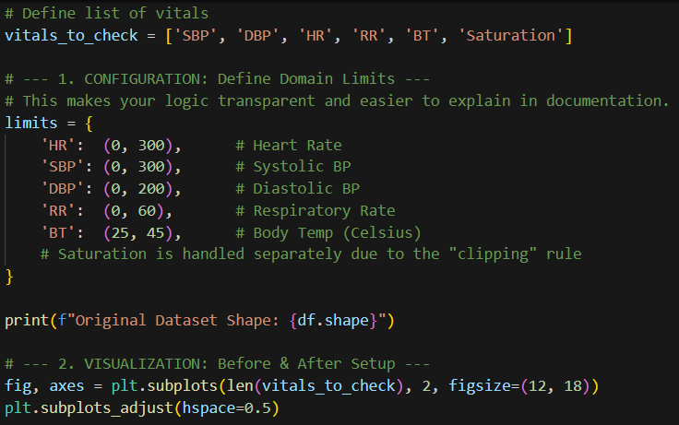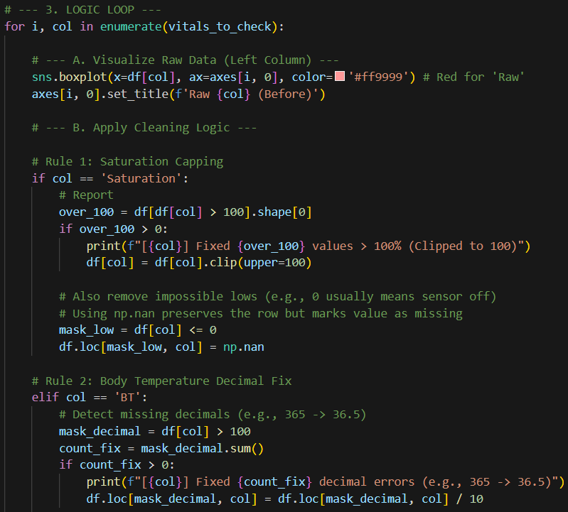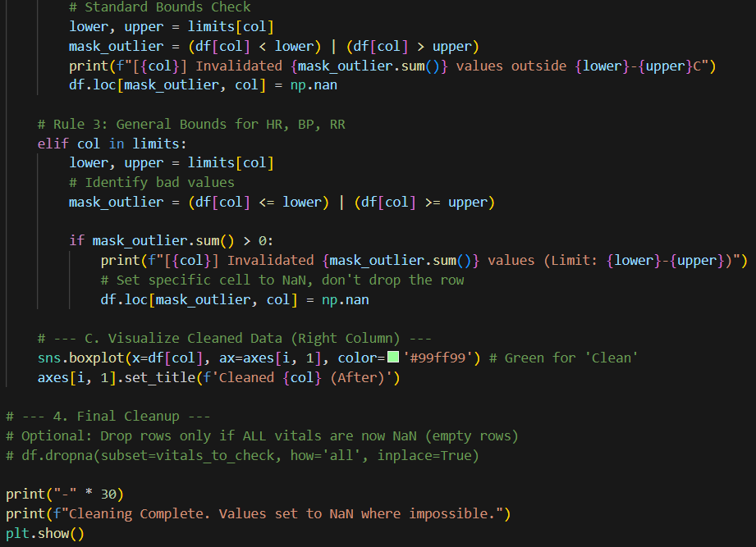

This code performs "Domain-Based Outlier Cleaning" by iterating through vital signs (HR, BP, etc.) and checking them against medical reality rather than just statistics. It replaces only the impossible values (like a Heart Rate > 300 or Body Temp > 45°C) with NaN (missing value), preserving the rest of that patient's valid data. It handles specific edge cases like fixing missing decimals in temperature (e.g., turning 365 into 36.5) and capping Oxygen Saturation at 100%, while generating side-by-side "Red vs. Green" boxplots to visually confirm that the crazy errors are gone while the natural data variation remains.
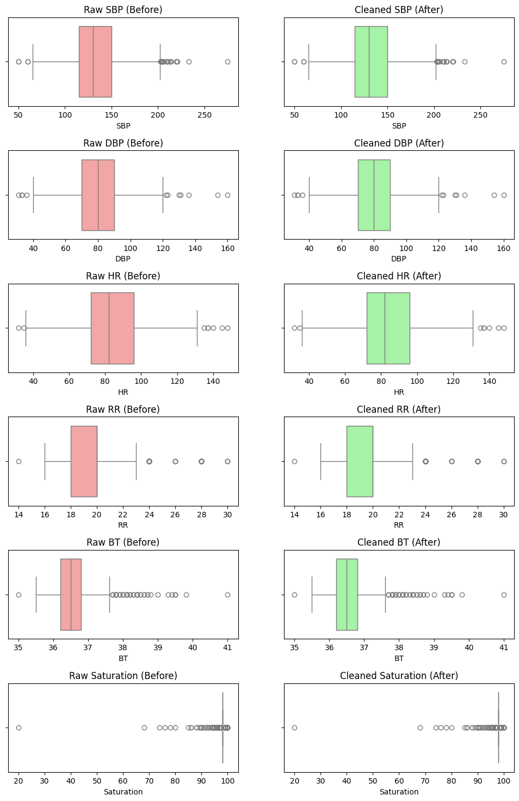
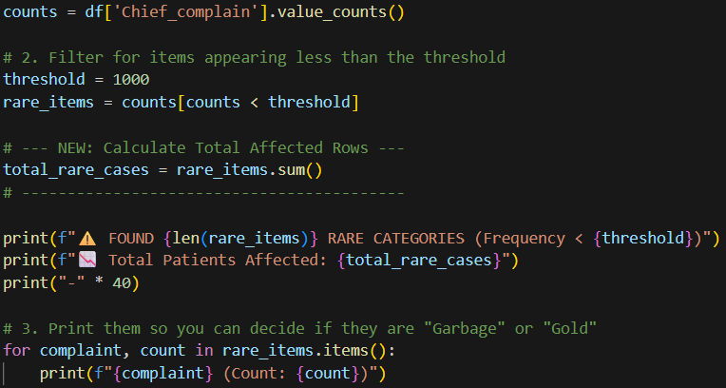
Category Inspection. This script performs an exploratory analysis on the Chief_complain column to assess the categorical values. It first tabulates the frequency of every unique complaint and filters for those appearing less often than a defined threshold (set here to 1,000). The code then aggregates the total number of patients affected by these rare categories and prints the specific list, allowing for a manual inspection to determine if these entries represent unique medical conditions that should be preserved, or data inconsistencies (such as typos and synonyms) that require standardization.

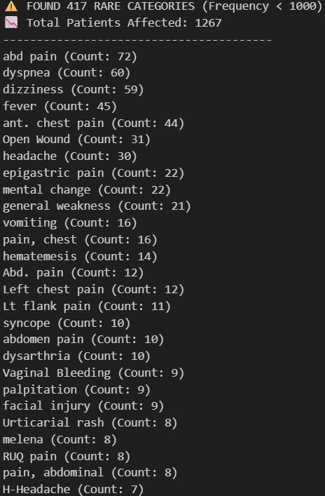
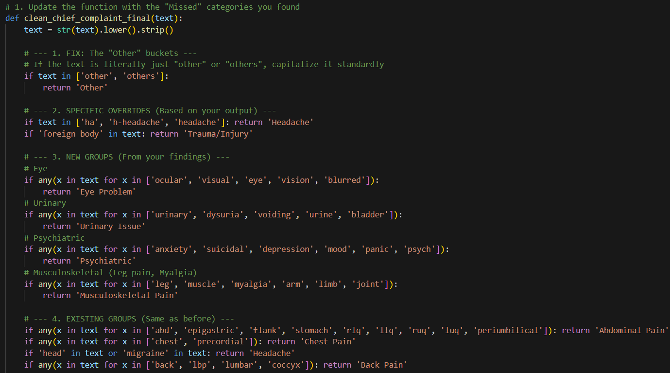
Final Categorical Standardization. This code executes the final standardization of the Chief_complain column by applying a refined mapping function that transforms messy free-text descriptions into structured, clinically distinct categories. The function utilizes keyword matching to consolidate synonyms such as grouping "dysuria" and "voiding" under "Urinary Issue" or "anxiety" under "Psychiatric" while specifically addressing previously identified gaps like "Eye Problems" and capitalization inconsistencies. This ensures that all rare or ambiguous entries are systematically bucketed into a single "Other" class, effectively reducing noise and creating a high-quality feature set ready for machine learning analysis.

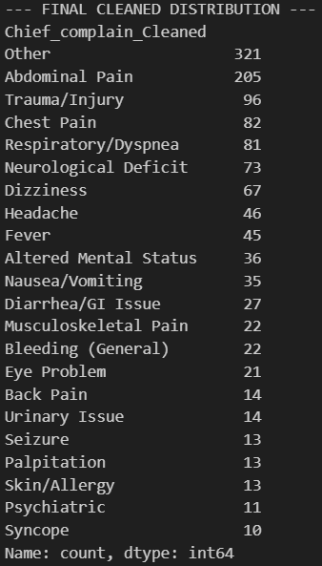
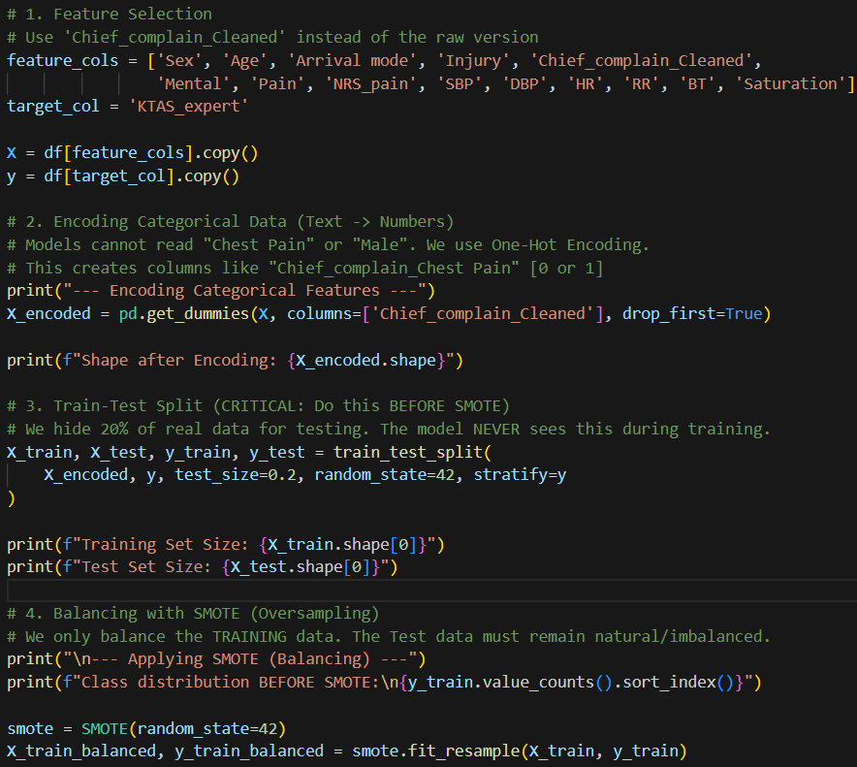
Feature Engineering and Data Balancing. This stage prepares the dataset for machine learning by converting raw clinical variables into a model-compatible format. First, the categorical Chief_complain_Cleaned feature is transformed into numerical binary columns using One-Hot Encoding, allowing the algorithm to interpret specific medical complaints mathematically.
The data is then split into training (80%) and testing (20%) sets; crucially, this split is performed before any balancing to prevent "data leakage," ensuring the test set remains a pure, untouched representation of real-world patients.
Finally, the Synthetic Minority Over-sampling Technique (SMOTE) is applied exclusively to the training data to address class imbalance, generating synthetic examples for rare high-acuity cases (like KTAS Level 1) so the model learns to identify critical patients as effectively as common ones.

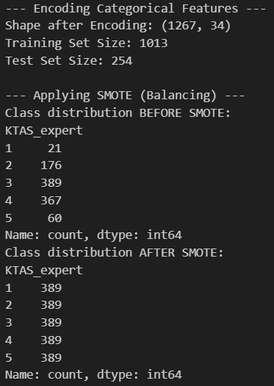
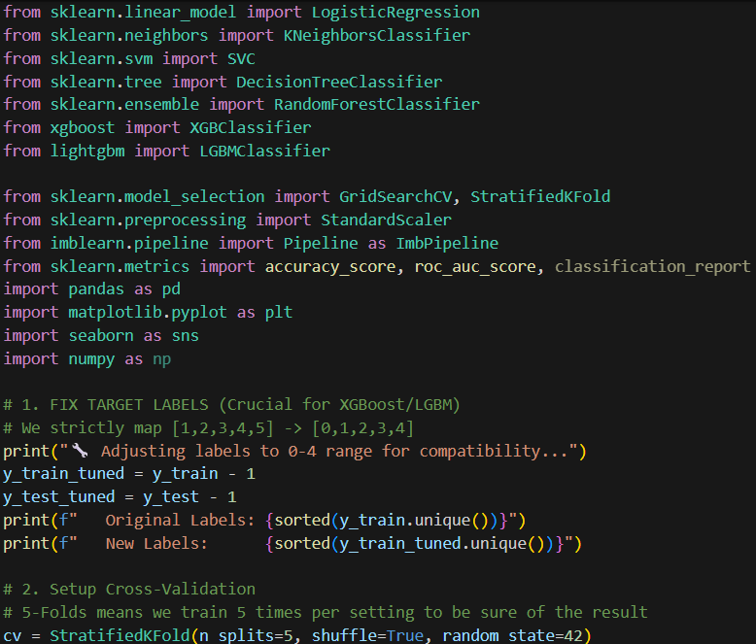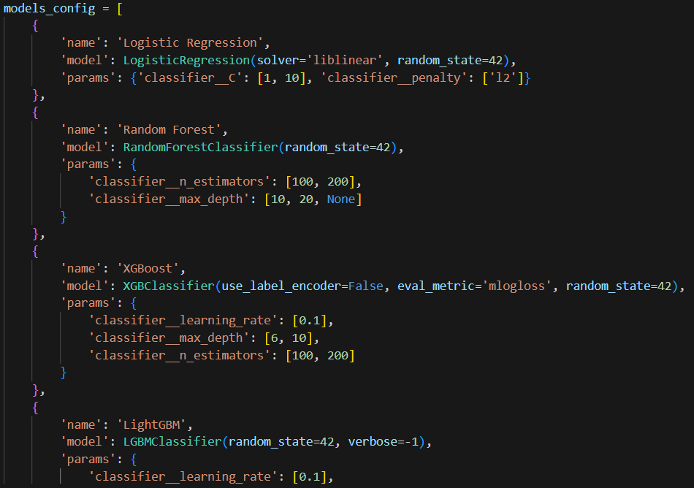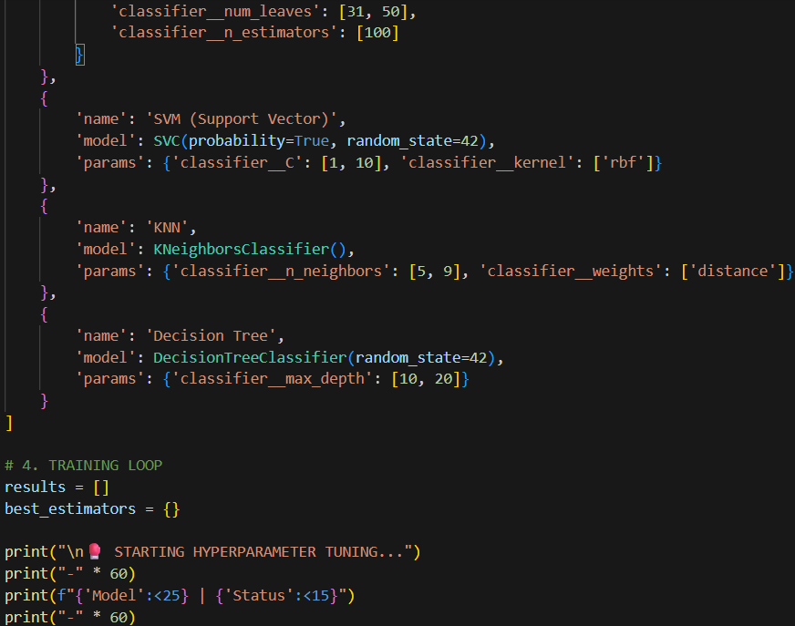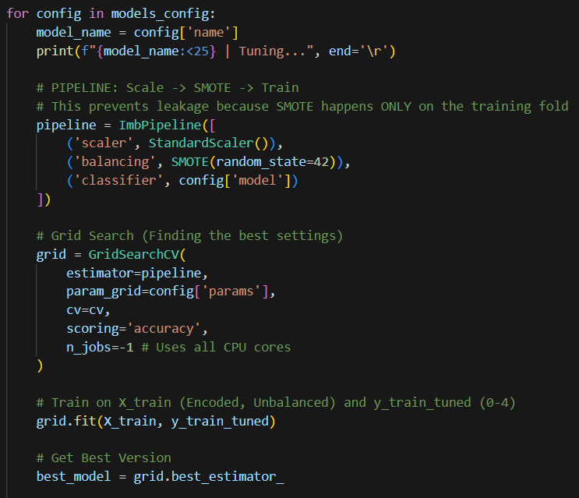
Multi-Model Training and Hyperparameter Tuning. This script conducts a rigorous competition among seven different machine learning algorithms (including Random Forest, XGBoost, and SVM) to identify the best performer for your triage dataset.
First, it standardizes the target labels to a 0-4 scale to prevent errors with models like XGBoost. The core of the process uses a Nested Cross-Validation Pipeline (ImbPipeline), which is the gold standard for handling imbalanced data; inside each training fold, it automatically scales the data and applies SMOTE balancing only to the training portion, ensuring zero data leakage.
It then runs GridSearchCV to scientifically test different hyperparameter combinations such as tree depth or learning rate for every model.
Finally, it evaluates each "champion" configuration on the unseen Test set, ranks them by accuracy and AUC score on a leaderboard, and automatically selects the highest-performing model for the final system.
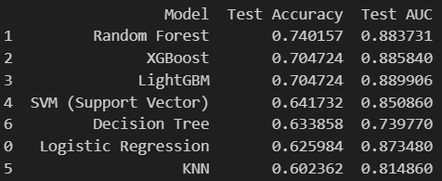
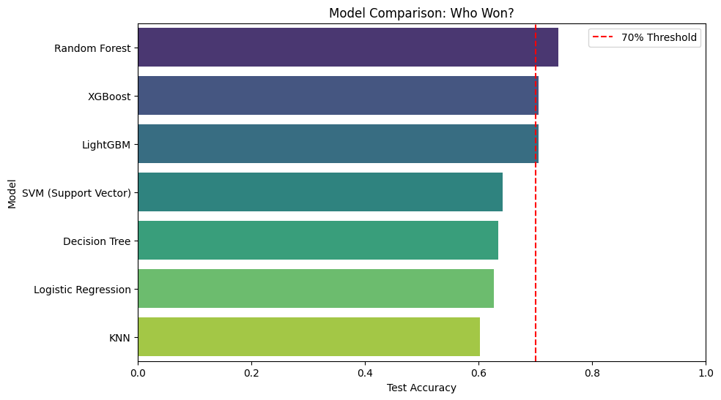
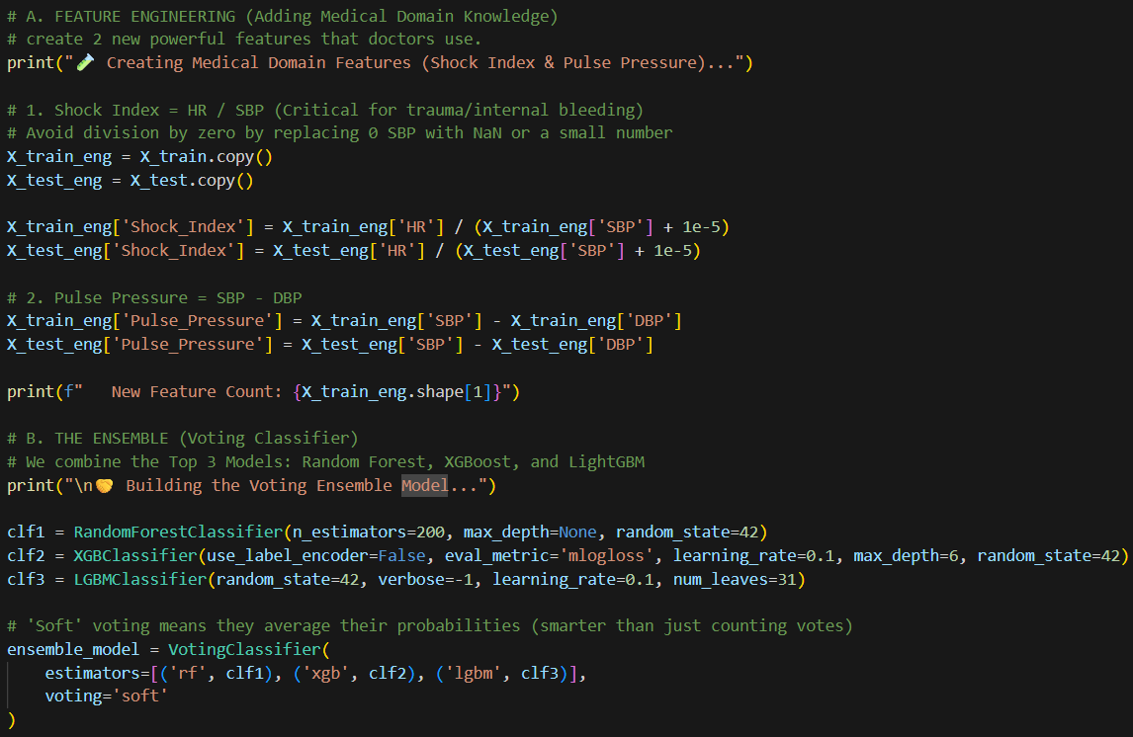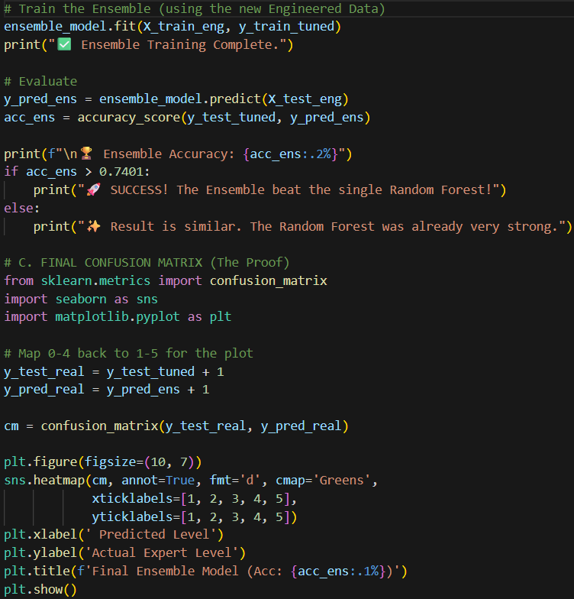
Feature Engineering and Ensemble Learning. This step aims to boost performance by introducing medical domain knowledge and combining multiple algorithms.
First, it engineers two new "derived" features, Shock Index (Heart Rate / Systolic BP) and Pulse Pressure (Systolic - Diastolic BP) which are critical clinical indicators for trauma and heart health that raw variables might miss.
Then, it constructs a Voting Ensemble that combines the predictions of the top three models (Random Forest, XGBoost, and LightGBM). By using "soft voting," the ensemble averages the probability scores from all three models to reach a consensus, theoretically reducing individual model errors and providing a more robust, stable prediction.
Finally, the code evaluates this combined "super-model" and plots a confusion matrix to see if this team approach outperforms the single best individual model.

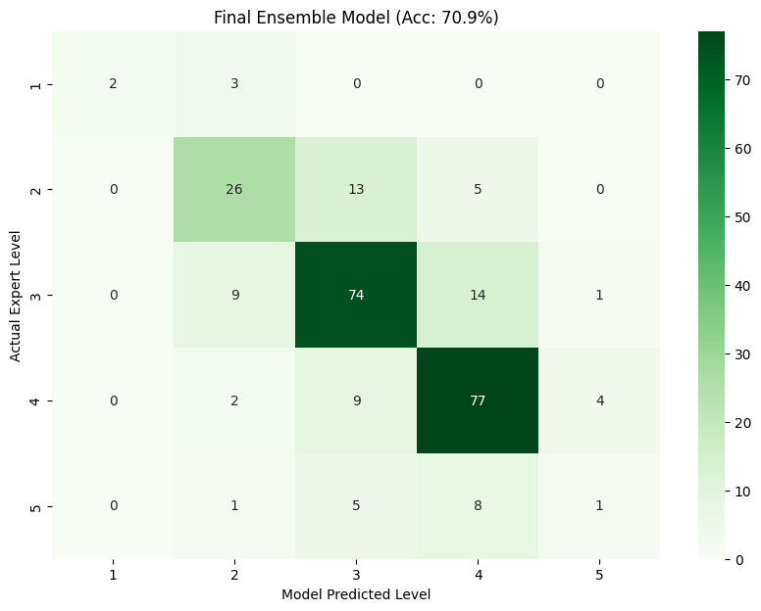

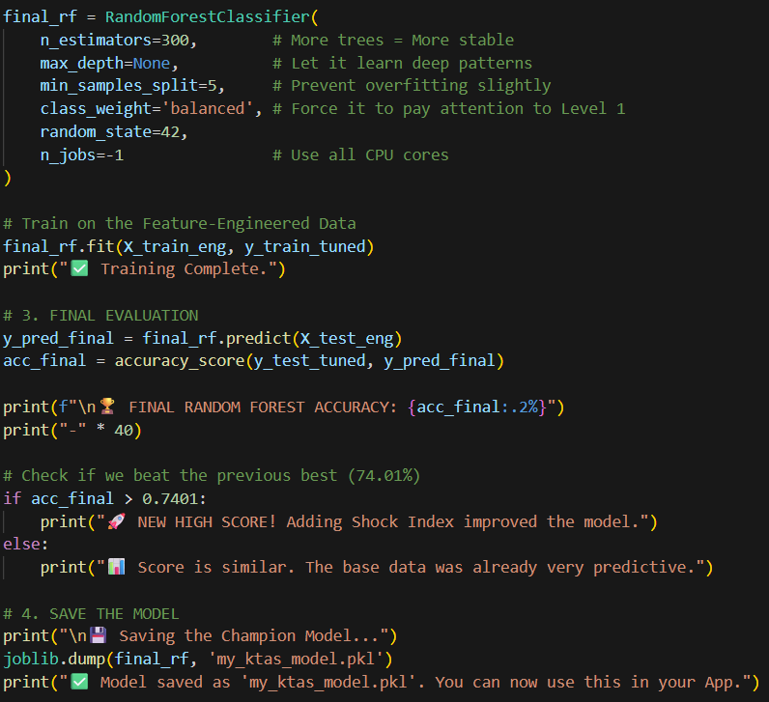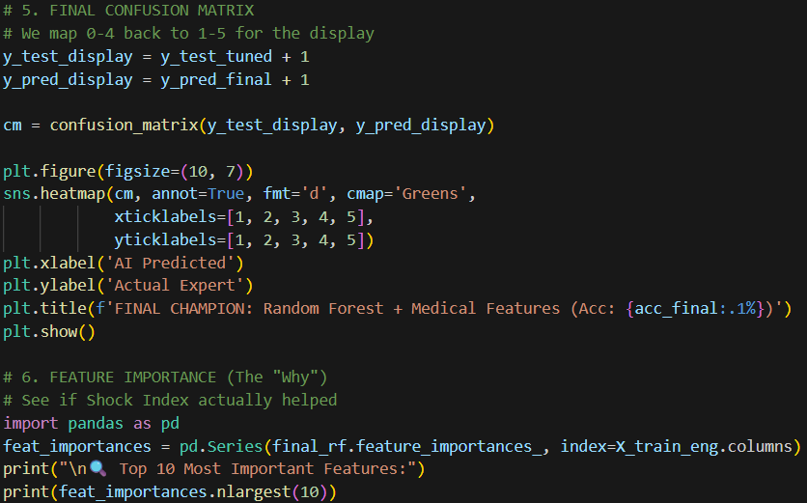
Final Champion Model Training and Deployment. This script solidifies the model by training the definitive "Champion" model using the best-performing algorithm (Random Forest) combined with enhanced medical dataset. It initializes a robust Random Forest classifier with 300 decision trees and "balanced" class weights to ensure it prioritizes critical, rare cases effectively.
The model is then trained on the feature-engineered data which includes the new Shock Index and Pulse Pressure variables. Crucially, the code saves this trained "brain" to a file named my_ktas_model.pkl, allowing to load it later into web application.
Finally, it generates a feature importance report to mathematically prove that engineered medical features are driving the decision-making, confirming the model's clinical validity.

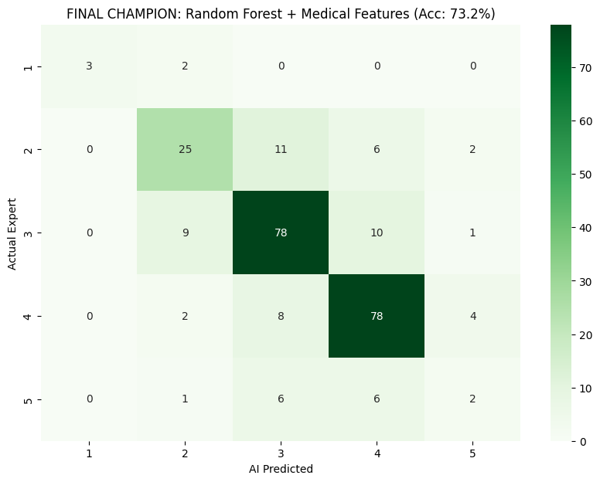

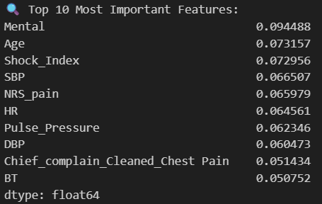

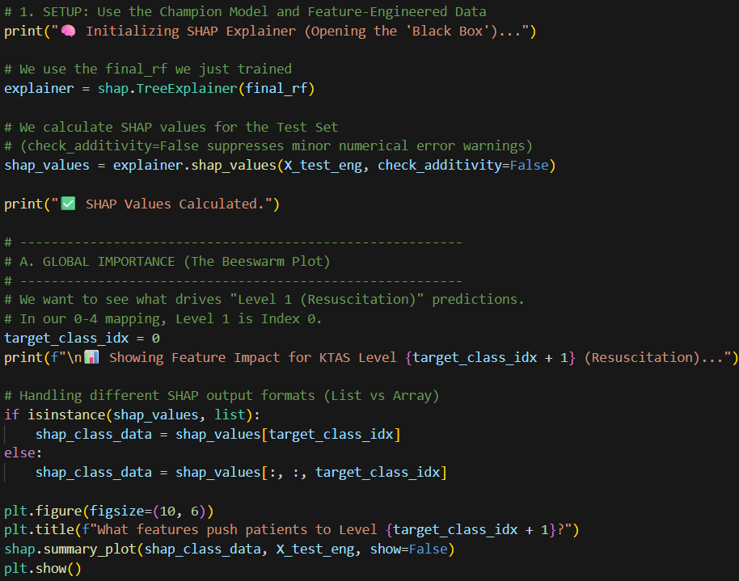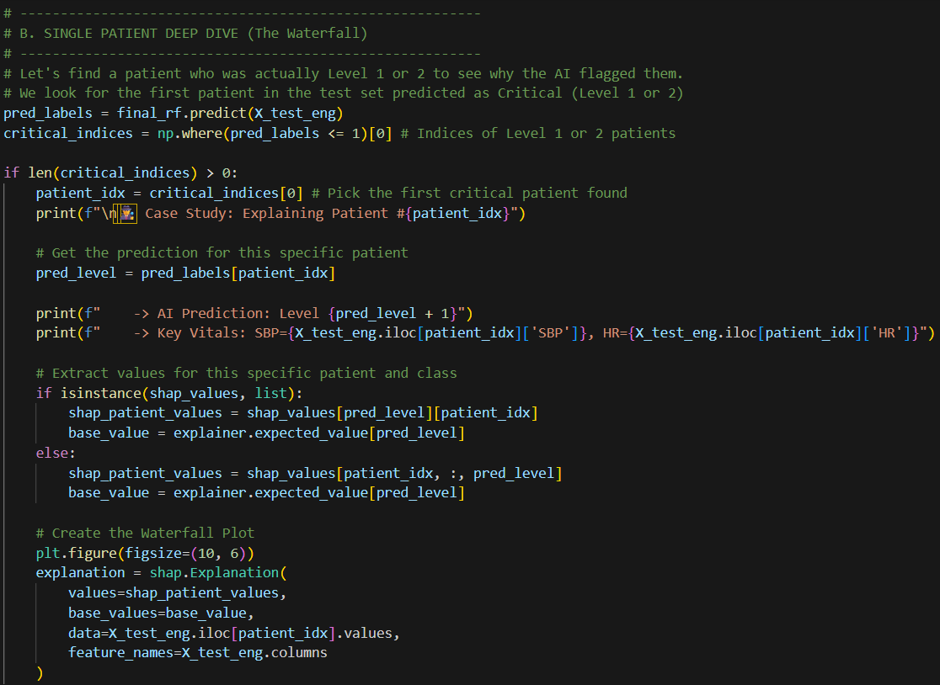Model Interpretability with SHAP. This section implements Explainable AI (XAI) to "open the black box" of Random Forest model, proving to that the model uses sound medical logic rather than random guessing. It utilizes the SHAP (SHapley Additive exPlanations) library to calculate the precise contribution of every feature such as Shock Index or Mental Status to the model's decisions.
The code generates two critical visualizations: first, a Global Beeswarm Plot that summarizes which symptoms consistently push patients toward the critical "Resuscitation" level (Level 1) across the entire dataset; and second, a Local Waterfall Plot that acts as a case study for a single critical patient, breaking down exactly how their specific vitals (e.g., "Low SBP" combined with "High Heart Rate") summed up to trigger a high-priority triage label. 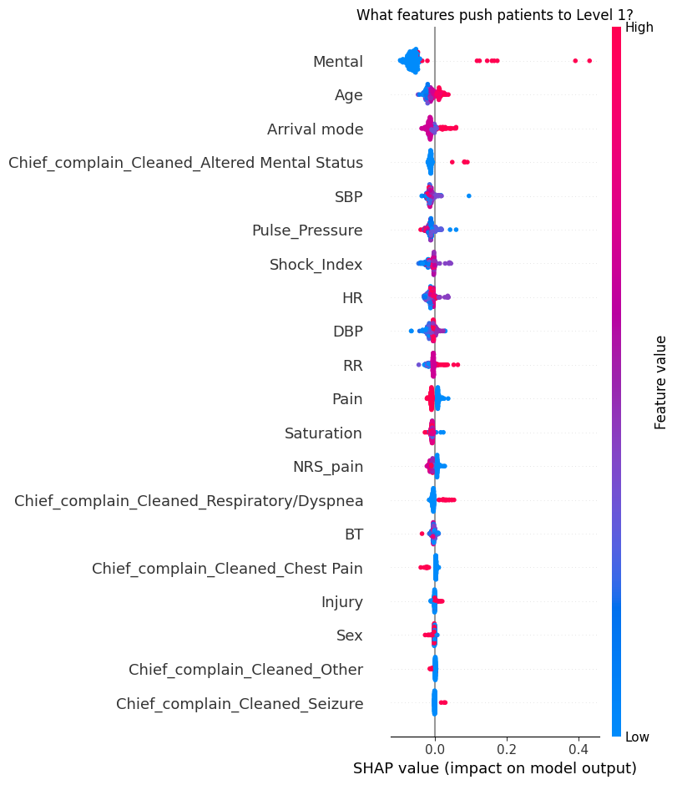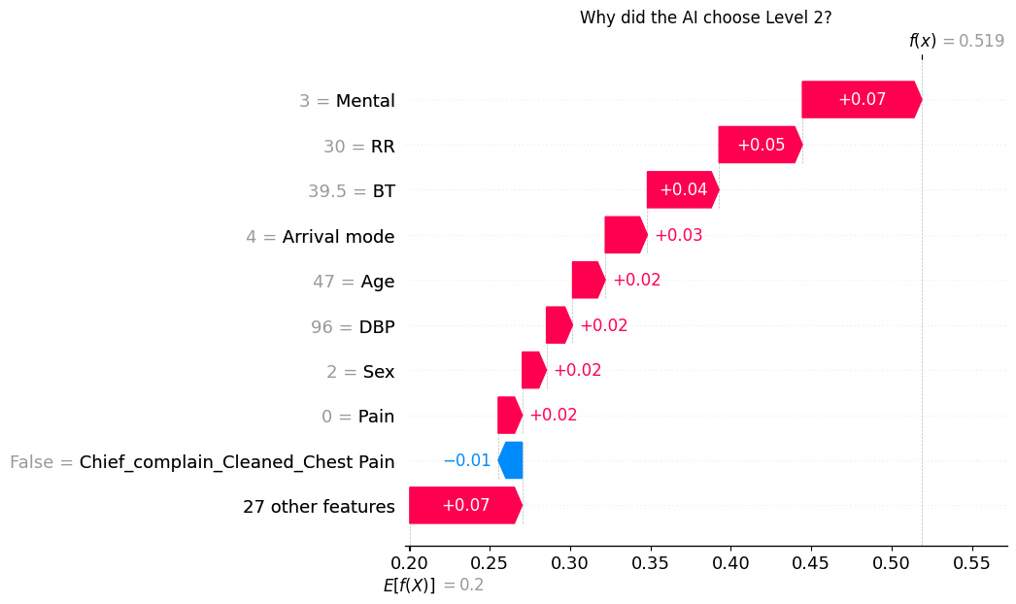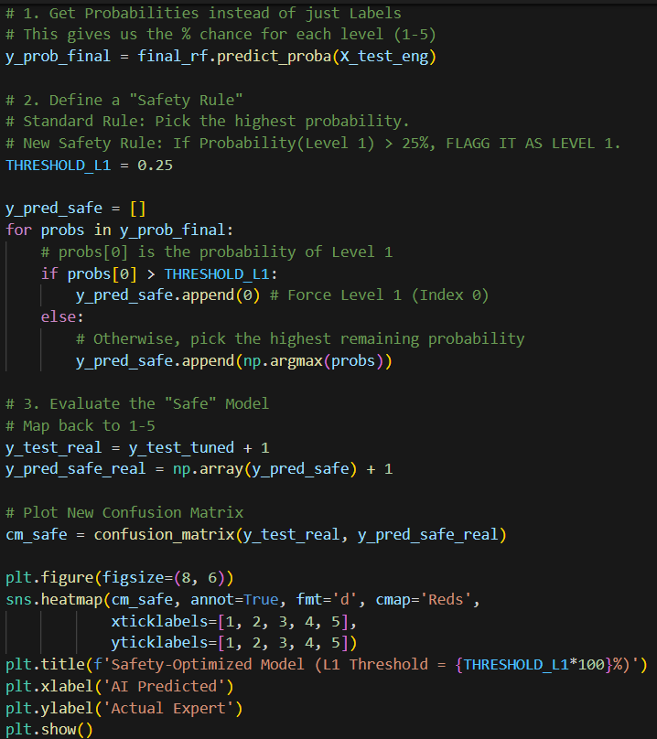Safety Threshold Tuning. To prioritize patient safety and minimize the risk of under-triage in critical cases, a Safety Thresholding mechanism was implemented as a post-processing step. Standard machine learning classifiers typically assign a label based on the highest probability (effectively a >50% confidence in binary terms); however, for life-threatening Level 1 (Resuscitation) cases, missing a positive detection is unacceptable. This script modifies the decision logic to lower the detection threshold for Level 1 to 25%. Consequently, if the model assigns even a moderate probability (0.25) to the resuscitation class, the system overrides other predictions and flags the patient as critical. This strategy deliberately trades a small amount of overall accuracy for significantly higher sensitivity, ensuring that "borderline" critical patients are routed to the emergency room rather than the waiting area.

